|  |  |
| --- | --- |
|  | 2025MEMBERHSIP DUES |
|  |  |

**SELECT A DUES CATEGORY:**

❑ **Active Member $250**

**Pay your dues online at *tinyurl.com/AUN2025Membership* or mail payment and form to:   
AUN | c\o Meghan Martin | PO Box 1900 | Montgomery, AL 36102. If your practice would like a group bill for all physicians in your practice, email *cculpepper@alamedical.org*.**

**Contact Information for Member**

***Please print legibly.***

Name of Member:

Company Name:

Mailing Address:

City, State and Zip:

Work Phone Number: (_____)

Cell Phone Number: (_____)

Cell phones are only used for important academy business by the executive director or physician board members.

Please check this box if you agree to opt into our text messaging system.

E-mail Address:

Office Manager:

Office Manager’s E-mail Address

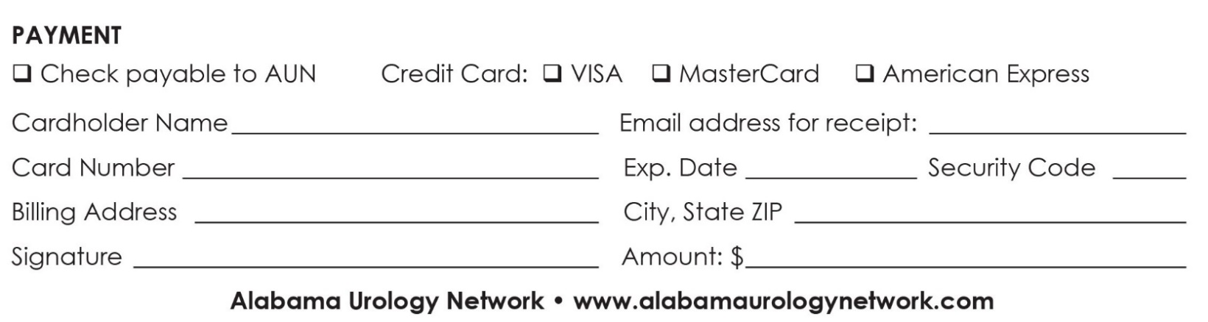

**THANK YOU FOR YOUR MEMBERSHIP!**